Dataset Description:

Image Count:  
Tomato Plant- It has 10 classes,

1. Tomato Bacterial Spot: **2127 images**
2. Tomato Early blight: **1000 images**
3. Tomato Late blight: **1909 images**
4. Tomato Leaf Mold: **952 images**
5. Tomato Septoria Leaf Spot: **1771 images**
6. Tomato Spider mites Two spotted spider mite: **1676 images**
7. Tomato Target Spot: **1404 images**
8. Tomato Yellow Leaf Curl Virus: **3209 images**
9. Tomato mosaic virus: **373 images**
10. Tomato healthy: **1591 images**

Potato Plant- It has 3 classes,

1. Potato Late Blight: **1000 images**
2. Potato Early Blight: **1000 images**
3. Potato Healthy: **152 images**

Pepper Plant- It has 2 classes,

1. Pepper bell Bacterial spot: **997 images**
2. Pepper bell healthy: **1478 images**

All Plant- Total we have 15 classes of the above 3 plants,

1. Tomato Bacterial Spot: **2127 images**
2. Tomato Early blight: **1000 images**
3. Tomato Late blight: **1909 images**
4. Tomato Leaf Mold: **952 images**
5. Tomato Septoria Leaf Spot: **1771 images**
6. Tomato Spider mites Two spotted spider mite: **1676 images**
7. Tomato Target Spot: **1404 images**
8. Tomato Yellow Leaf Curl Virus: **3209 images**
9. Tomato mosaic virus: **373 images**
10. Tomato healthy: **1591 images**
11. Potato Late Blight: **1000 images**
12. Potato Early Blight: **1000 images**
13. Potato Healthy: **152 images**
14. Pepper bell Bacterial spot: **997 images**
15. Pepper bell healthy: **1478 images**

**Total images: 20,639 images**

**Pixel: 256*256**

Comparison of Results:

Potato Plant, Epoch 10:

80:20 Train Test Spilt

75:25 Train Test Spilt

70:30 Train Test Spilt

60:40 Train Test Spilt

Comparison of Results:

Pepper Bell Plant, Epoch 10:

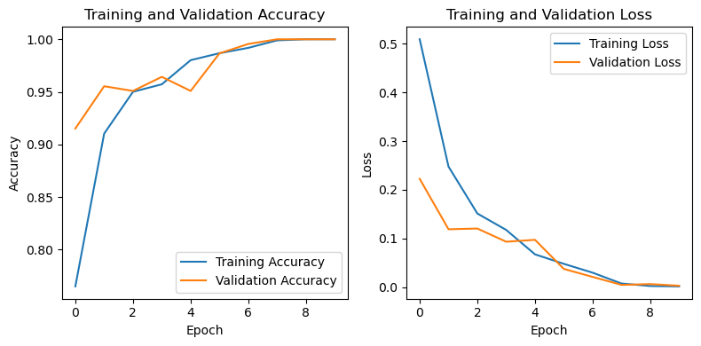

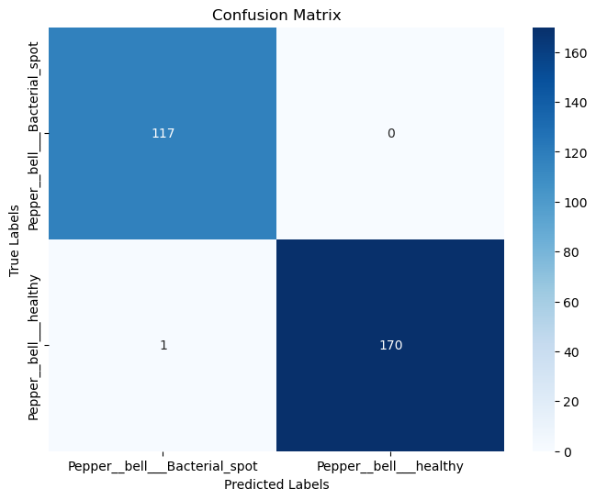

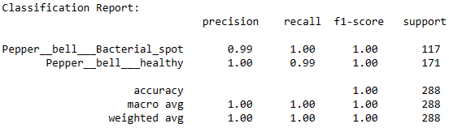

80:20 Train Test Spilt

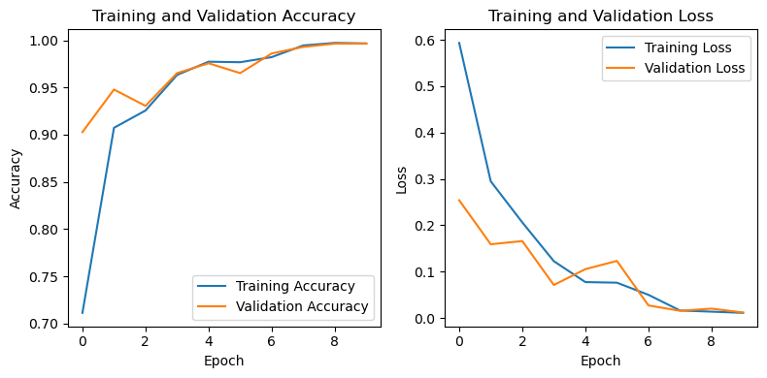

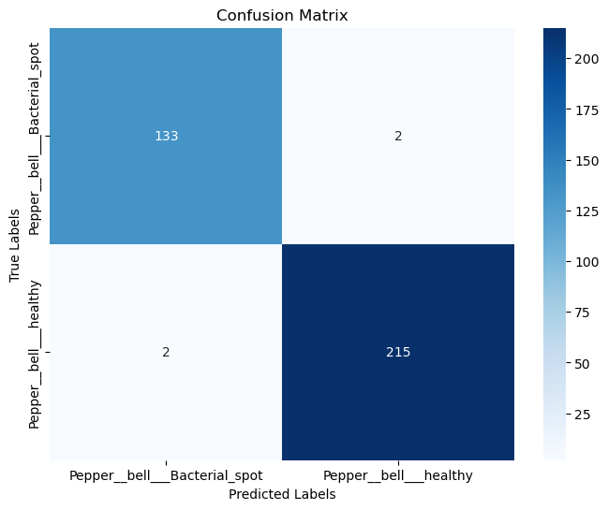

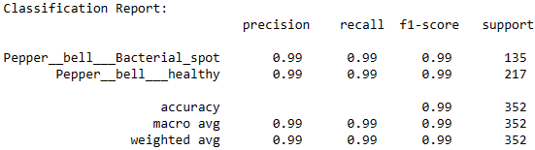

75:25 Train Test Spilt

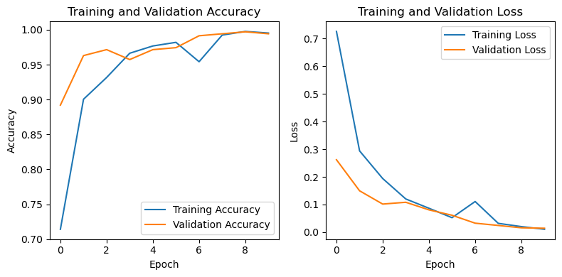

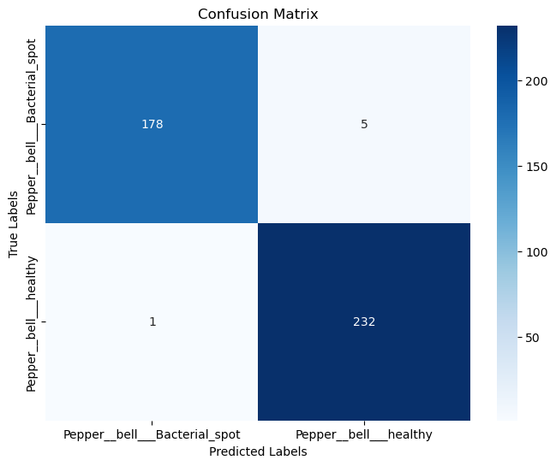

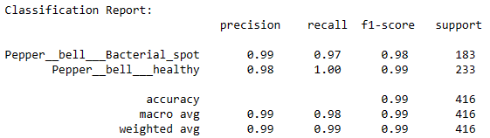

70:30 Train Test Spilt

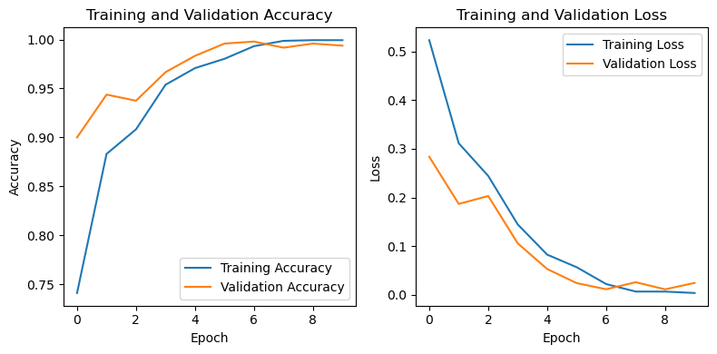

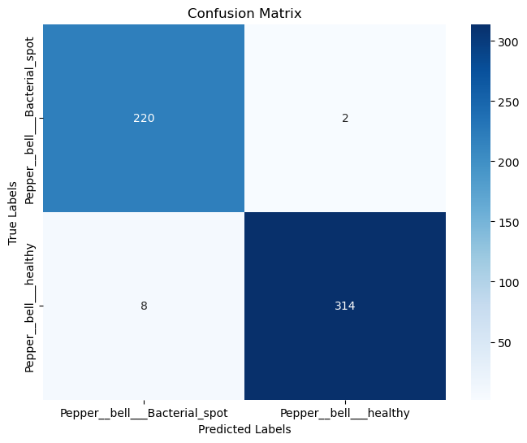

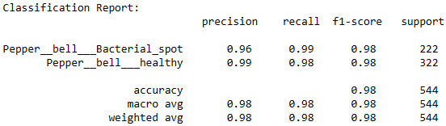

60:40 Train Test Spilt